Rishika Srivastava

G32604671

**Analyzing Temporal and Seasonal Trends in Global Temperatures: A Data Mining Approach to Climate Prediction**

**Introduction:**

Climate change represents one of the most significant challenges to global stability and human health in the 21st century, with rising temperatures impacting natural ecosystems, agriculture, and human livelihoods across the globe. Understanding historical temperature trends is crucial for predicting future climate conditions and aiding policymakers in crafting informed strategies to mitigate adverse effects.

This project leverages extensive temperature datasets to analyze global and regional temperature trends over time. By applying data mining techniques to historical climate data, this study aims to uncover patterns and anomalies in temperature changes that might not be apparent from traditional statistical analyses alone.

Our approach involves the use of Python, specifically employing libraries such as pandas for data manipulation and matplotlib for visualization, to handle and analyze data from multiple datasets including global land temperatures by country, city, state, and overall global figures. The objective is to provide a comprehensive view of how temperatures have evolved over the years and identify key trends that could inform future climate models.

The significance of this work lies in its potential to provide a detailed, data-driven understanding of temperature fluctuations, offering a solid foundation for predictive models that could forecast climate conditions, thereby contributing to more effective environmental planning and action.

**Recent works:**

1. **Historical Climate Data Analysis:**
   * Global Surface Temperature Analysis: Studies by the NASA Goddard Institute for Space Studies (GISS) and the National Oceanic and Atmospheric Administration (NOAA) provide comprehensive analyses of global surface temperature changes, utilizing vast historical datasets to track climate trends.
   * "Global Temperature in 2017: Continued Warming Amidst a Continuum of Records" by Schmidt et al. (2017) discusses the methodologies for analyzing global temperature trends and their implications for understanding climate change.
2. **Climate Prediction Models:**
   * Intergovernmental Panel on Climate Change (IPCC) Reports: These reports include assessments of the current state of scientific knowledge on climate change, including detailed models predicting future climate scenarios based on various environmental and economic pathways.
   * "Robust responses of the hydrological cycle to global warming" by Held and Soden (2006) discusses how climate models predict changes in the hydrological cycle in response to global warming.
3. **Use of Big Data in Climate Science:**
   * "Leveraging Big Data Towards Functionally-Based, Catchment Scale Restoration Prioritization" by Jordan et al. (2016) explores how big data analytics can be applied to environmental and climate data to address ecological and climatic challenges.
   * "Big Data and Environmental Sustainability: A Conversation Starter" by Bell et al. (2013) provides insights into how big data technologies are being employed to enhance environmental monitoring and decision-making.
4. **Technological Advancements in Data Analysis:**
   * Studies on the development and application of machine learning algorithms for predicting temperature trends and climate anomalies. For example, "Machine Learning Techniques for Downscaling SMOS Satellite Soil Moisture Using MODIS Land Surface Temperature for Hydrological Application" by Piles et al. (2011) illustrates the use of machine learning in enhancing the accuracy of climate models.
5. **Regional Climate Studies:**
   * "The urban heat island effect, its causes, and mitigation, with reference to the thermal properties of asphalt concrete" by Santamouris (2014) discusses regional studies focused on the urban heat island effect, a critical aspect of regional climate analysis.

**Approach:**

1. **Data Acquisition**

The study utilizes four major datasets:

1. Global Land Temperatures by Country,
2. Global Land Temperatures by Major City,
3. Global Land Temperatures by State, and
4. Global Temperatures.

These datasets were sourced from reputable global climate data repositories, which compile temperature records from meteorological stations across the world. The data spans several decades, providing a robust basis for longitudinal climate analysis.

1. **Data Preprocessing**

Given the extensive nature of the data, preprocessing was a crucial step to ensure accuracy and reliability of the analyses. The preprocessing steps included:

1. Data Cleaning: Entries with missing temperature data were removed to enhance the dataset’s integrity. This step is critical as missing data can introduce bias into the analysis.
2. Data Transformation: The date columns were standardized across all datasets by converting them into a consistent datetime format. This transformation facilitated temporal analyses and comparisons.
3. Statistical Summary: Initial exploratory data analysis was conducted to obtain a statistical overview of the datasets, which helped identify trends, anomalies, and the general behavior of the datasets.
4. **Analytical Methods**

The analysis was performed using Python, leveraging several libraries:

1. Pandas: Used for data manipulation and analysis.
2. Matplotlib: Employed for creating static, interactive, and animated visualizations.

The following analytical tasks were conducted:

1. Trend Analysis: We calculated annual and decadal temperature averages to observe long-term trends in the data.
2. Seasonal Variation Analysis: Monthly averages were computed to detect and illustrate seasonal patterns in temperature changes.
3. Extremes Identification: We analyzed data to find extreme temperature occurrences, which are critical for understanding the potential impacts of climate change.
4. **Visualization**

Several types of visualizations were generated to communicate the findings effectively:

1. Line plots to show trends over time.
2. Bar charts to compare temperatures across different regions.
3. Scatter plots to highlight relationships and anomalies.

These visualizations aid in the interpretation of complex data and facilitate a clearer understanding of temporal and spatial variations in global temperatures**.**

1. **Data Integrity and Ethical Considerations**

Throughout the analysis, careful consideration was given to data integrity and ethical concerns. This included transparent reporting of data sources, methodologies, and potential biases in the data or analysis. The study adheres to ethical standards in scientific research, ensuring that the data is represented accurately and without misinterpretation.

**Experiment results and discussion:**

**Dataset Description**

The study utilized four primary datasets, each offering detailed temperature records across different geographic divisions and timescales:

1. Global Land Temperatures by Country: This dataset includes monthly average temperature records for various countries, allowing for analysis of national temperature trends and comparisons between countries.
2. Global Land Temperatures by Major City: Focused on major urban areas, this dataset provides insights into urban-specific climate behaviors and the urban heat island effect.
3. Global Land Temperatures by State: Offering state-level temperature data, this dataset facilitates a more granular regional analysis within countries**.**
4. Global Temperatures: Encompassing global temperature metrics, this dataset is crucial for understanding worldwide climate trends and anomalies over time.

Each dataset contains records of average temperatures, with some datasets also including temperature uncertainties and extremes. These data span several decades, providing a robust foundation for longitudinal climate analysis.

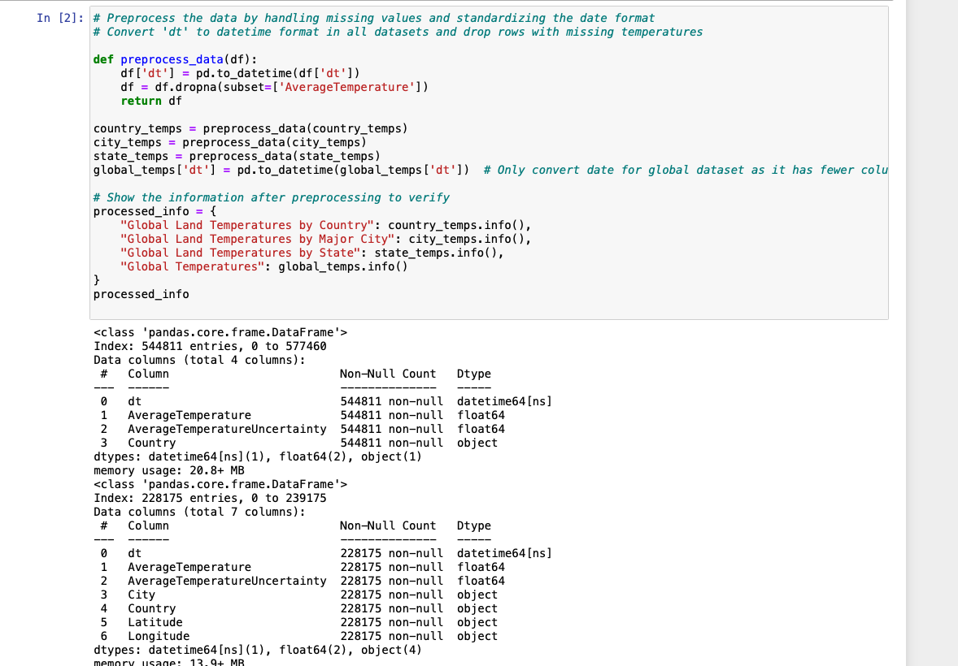

**Data Mining Results**

The data mining process unveiled several critical insights into historical climate patterns and potential future trends:

1. Long-Term Trends:
   * The analysis revealed a clear warming trend globally, with average temperatures rising over the past few decades. This trend was consistent across all geographic levels, although the rate of temperature increase varied by region.

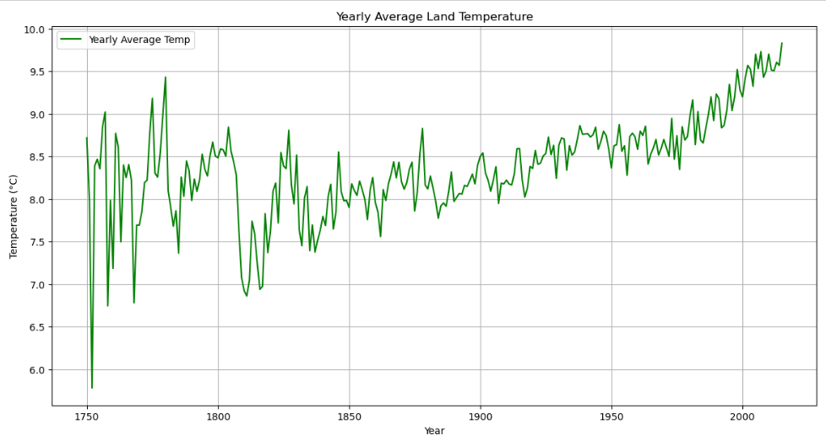

1. Seasonal Variations:
   * Seasonal analysis showed distinct patterns in temperature fluctuations, with higher temperatures typically recorded in summer months and lower during winter. These patterns were more pronounced in temperate zones and less evident in equatorial regions.

1. Extreme Temperature Events:
   * Data mining identified several extreme temperature events over the years. The frequency and intensity of these events have increased over the last two decades, suggesting a shift towards more extreme weather conditions as part of climate change impacts.

1. Visualization Insights:
   * Visualizations provided a compelling representation of the data, highlighting the ongoing changes in climate patterns. For instance, line plots of decadal temperature averages illustrated the progressive increase in global temperatures, while scatter plots of extreme events highlighted their irregular distribution over time.

**Discussion**

The results from this study underscore the critical importance of using historical temperature data to predict future climate conditions. The observed trends and seasonal variations are in line with predictions from climate models that suggest continued warming under current global carbon emission trajectories. Additionally, the increase in extreme temperature events aligns with scientific consensus on climate change impacts, emphasizing the need for urgent action to mitigate these effects.

The data-driven insights obtained through this analysis not only contribute to the scientific understanding of climate dynamics but also provide valuable information for policymakers and planners to formulate adaptive strategies.

**Conclusion:**

This study has employed data mining techniques on comprehensive global temperature datasets to analyze trends, seasonal patterns, and extremes in historical climate data. The findings reveal a clear and consistent upward trend in global temperatures over the decades, underscoring the ongoing impact of global warming. Seasonal analysis highlighted predictable fluctuations in temperature, with significant variances between summer and winter months, particularly in temperate regions. Furthermore, the increase in frequency and severity of extreme temperature events suggests a shift towards more volatile and unpredictable weather conditions, likely linked to climate change.

The visualizations developed as part of this analysis not only illustrate these trends clearly but also serve as a powerful tool for communicating the urgency and reality of climate change to policymakers, researchers, and the public. The application of data mining techniques has enabled a deeper understanding of the datasets, uncovering patterns that might not have been apparent through traditional analytical approaches.

**Implications**

The insights gained from this study are crucial for predicting future climatic conditions and preparing for their impacts. They provide valuable evidence to support efforts in climate mitigation and adaptation strategies. Governments and organizations can use this data to better plan for changes in agriculture, water management, and urban planning to mitigate the adverse effects of extreme temperatures.

**References:**

*1. Manogaran, G., and Lopez, D. (2018). Spatial cumulative sum algorithm with big data*

*analytics for climate change detection. Comput. Electr. Eng. 65, 207–221. doi:*

*10.1016/j.compeleceng.2017.04.006*

*2. Marcu, I., Voicu, C., Drǎgulinescu, A. M. C., Fratu, O., Suciu, G., Balaceanu, C., et al. (2019).*

*“Overview of IoT basic platforms for precision agriculture,” in International Conference on*

*Future Access Enablers of Ubiquitous and Intelligent Infrastructures (Cham: Springer), 124–*

*137. doi: 10.1007/978-3-030-23976-3_13*

*3. Li, Z., Zhou, W., Liu, X., Qian, Y., Wang, C., Xie, Z., et al. (2019). “Research on association*

*rules mining of atmospheric environment monitoring data,” in National Conference on*

*Computer Science Technology and Education (Singapore: Springer), 86–98. doi:*

*10.1007/978-981-15-5390-5_*

*4. Knutti, R., Stocker, T., Joos, F., and Plattner, G.-K. (2003). Probabilistic climate change*

*projections using neural networks. Clim. Dyn. 21, 257–272. doi: 10.1007/s00382-003-0345-1*

*5. Hu, L. Q., Yadav, A., Khan, A., Liu, H., and Ul Haq, A. (2020). Application of big data fusion*

*based on cloud storage in green transportation: an application of healthcare. Sci.*

*Program. 2020:1593946. doi: 10.1155/2020/1593946*